python鼠标键盘屏幕常用操作

功能
使用python实现控制鼠标键盘屏幕常用操作

环境
Win10 64bit Python 3.6.13 conda 4.9.2
conda activate torch170

win32core 221.36
win32gui 221.6
PyAutoGUI 0.9.53
PyGetWindow 0.0.9

鼠标操作
mouse01.py
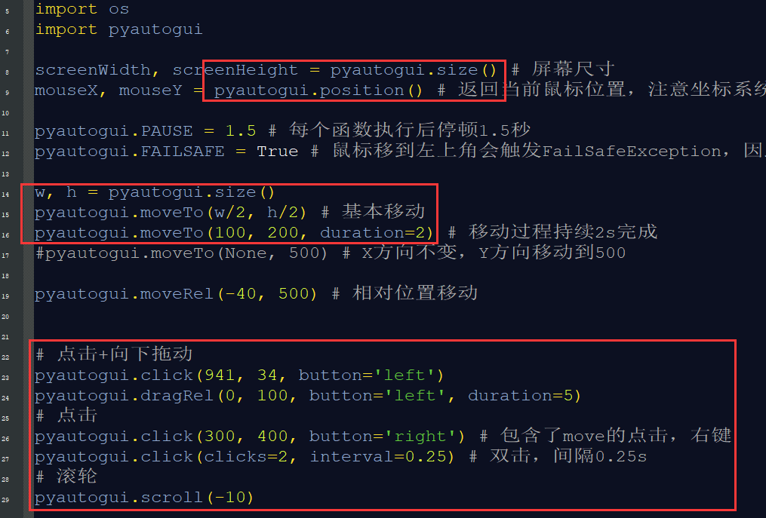
(torch170) PS D:\examples_python\mouse-keyboard-screen> python .\mouse01.py
mouse02实时显示鼠标位置
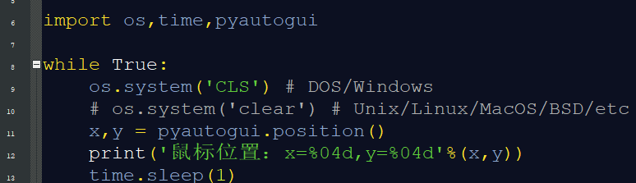
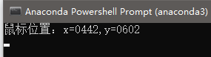

键盘操作
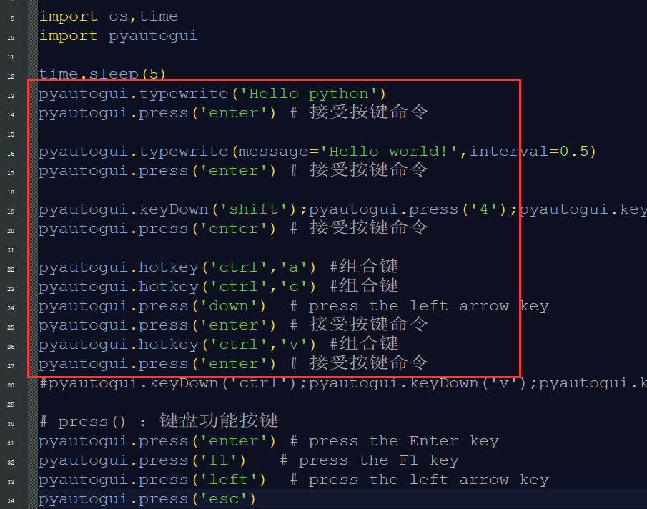

先打开word，切换成英文输入法，等待程序运行
(torch170) PS D:\examples_python\mouse-keyboard-screen> python .\key01.py
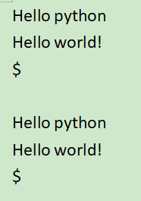

屏幕操作
screen01-pillow实现实时屏幕显示
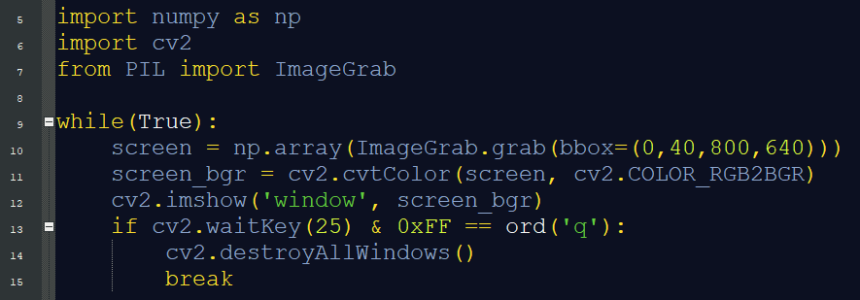
screen03-pillowmail屏幕截图并发送邮件
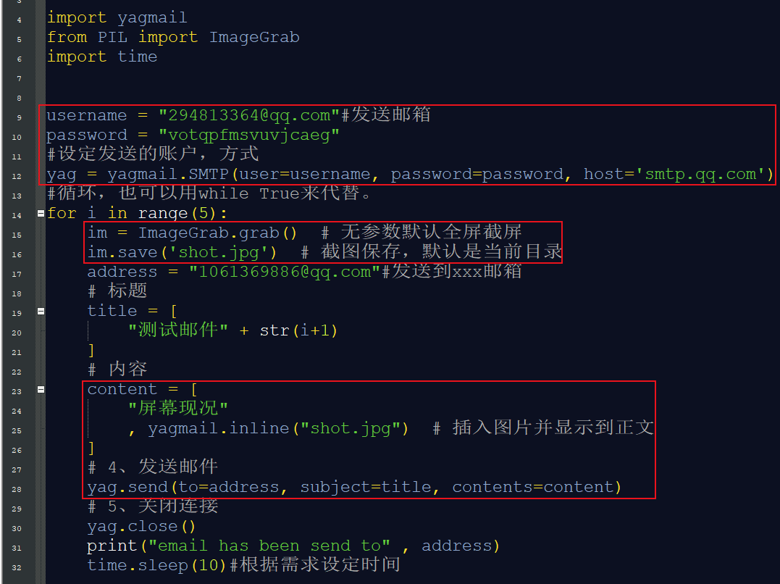
screen02-PyQt每间隔几秒截图并保存
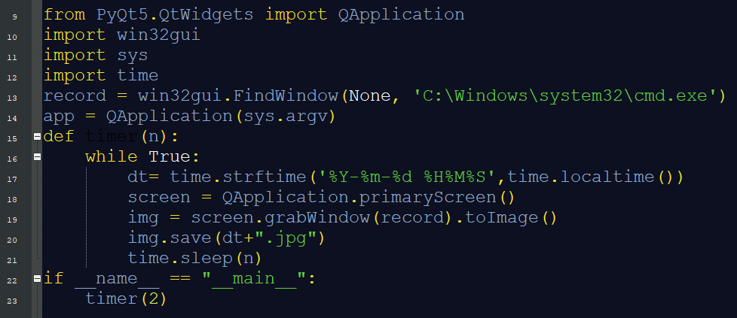
回到基础环境运行 > conda activate base
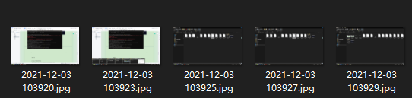
screen05-win32gui + PyQt截取指定窗口并保存图片
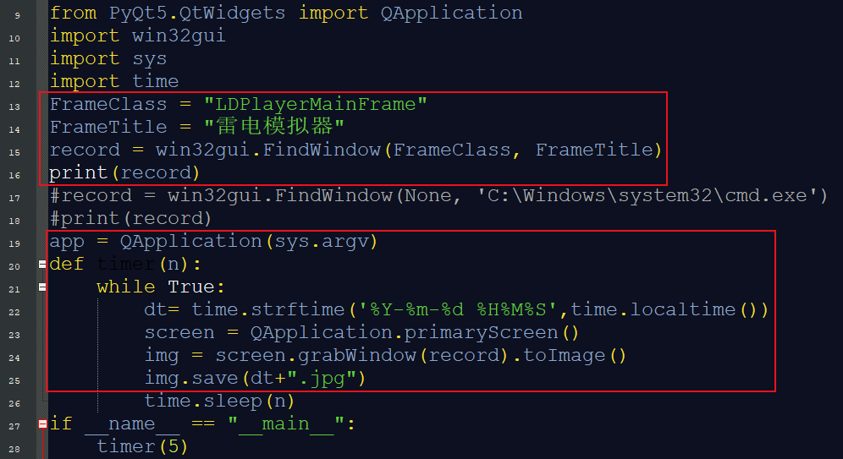
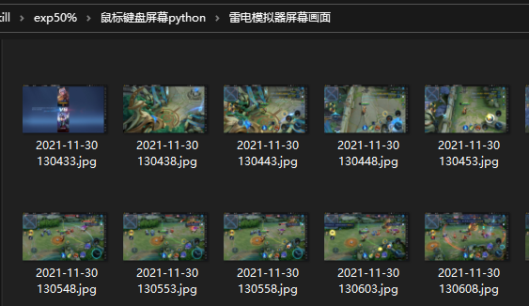
screen04-pyautogui 屏幕截图+logo查找定位+像素匹配
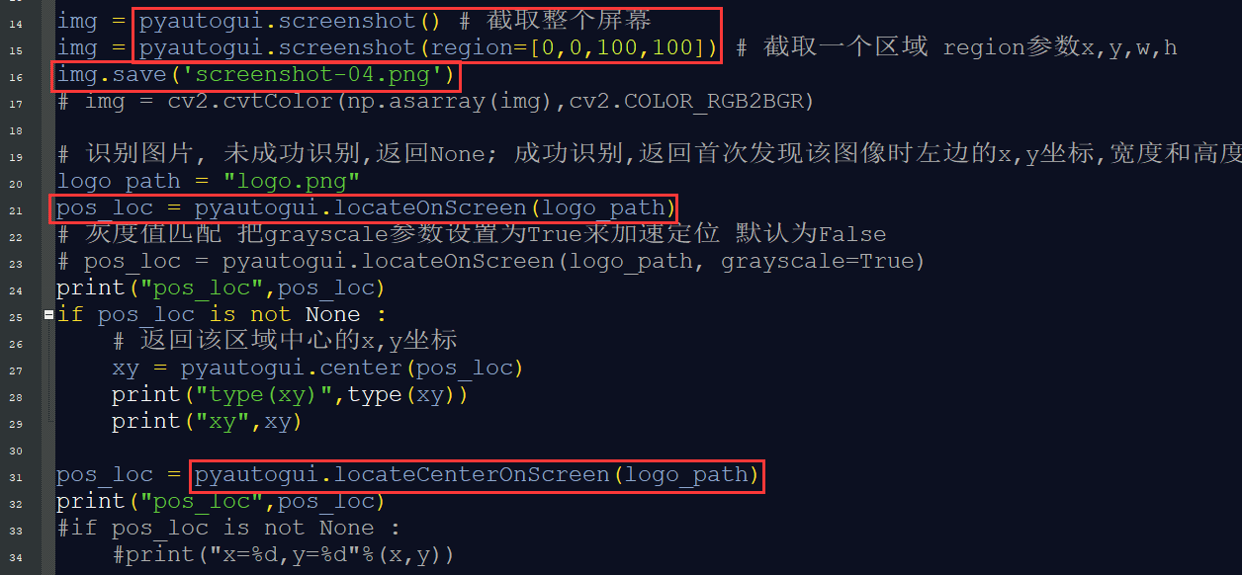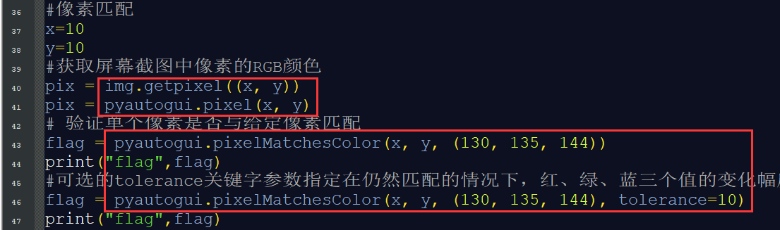
(torch170) PS D:\examples_python\mouse-keyboard-screen> python .\screen04-pyautogui.py
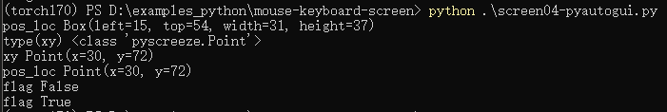
需要在这个屏幕条件下运行代码，logo匹配才能成功！
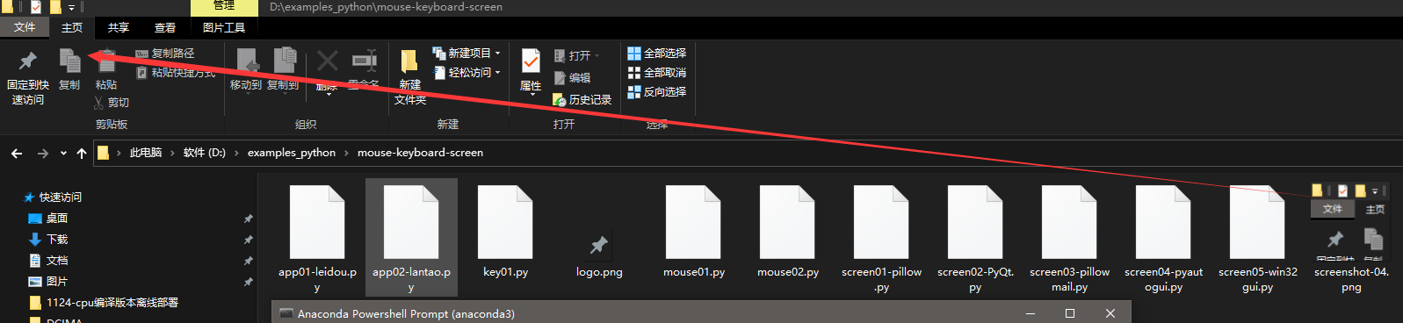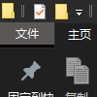

知识点
1.Python获取屏幕截图的4种方法
https://blog.csdn.net/jokerzhanglin/article/details/117201541

2.win32gui.Findwindow窗口句柄获取
https://blog.csdn.net/ztmajor/article/details/105376319
https://www.cnblogs.com/aziji/p/10483242.html
https://blog.csdn.net/ztmajor/article/details/105376319
https://www.cnblogs.com/aziji/p/10483242.html
https://www.cr173.com/soft/30801.html
http://www.jiuaitu.com/python/398.html

3.pyautogui库的最全使用方法
https://blog.csdn.net/qingfengxd1/article/details/108270159

4.Python 控制鼠标和键盘
https://blog.csdn.net/weixin_46089319/article/details/106687000
https://www.cnblogs.com/fanghao/p/8453207.html
https://www.cnblogs.com/ycx1024/p/14055506.html
5.屏幕输出
https://blog.csdn.net/nominior/article/details/83721050
https://www.cnpython.com/qa/319287

问题
1.python通过SMTP协议发送邮件失败
smtplib.SMTPAuthenticationError: (535, b'Login Fail. Please enter your authorization code to login. More information in http://service.mail.qq.com/cgi-bin/help?subtype=1&&id=28&&no=1001256')
https://www.cnblogs.com/yanwangye/p/12503030.html
https://blog.csdn.net/qq_45829545/article/details/113373389
https://blog.csdn.net/fjx1173865548/article/details/57084620
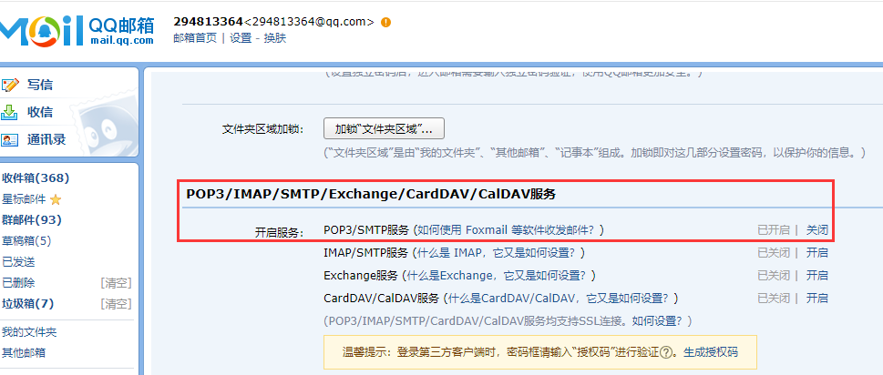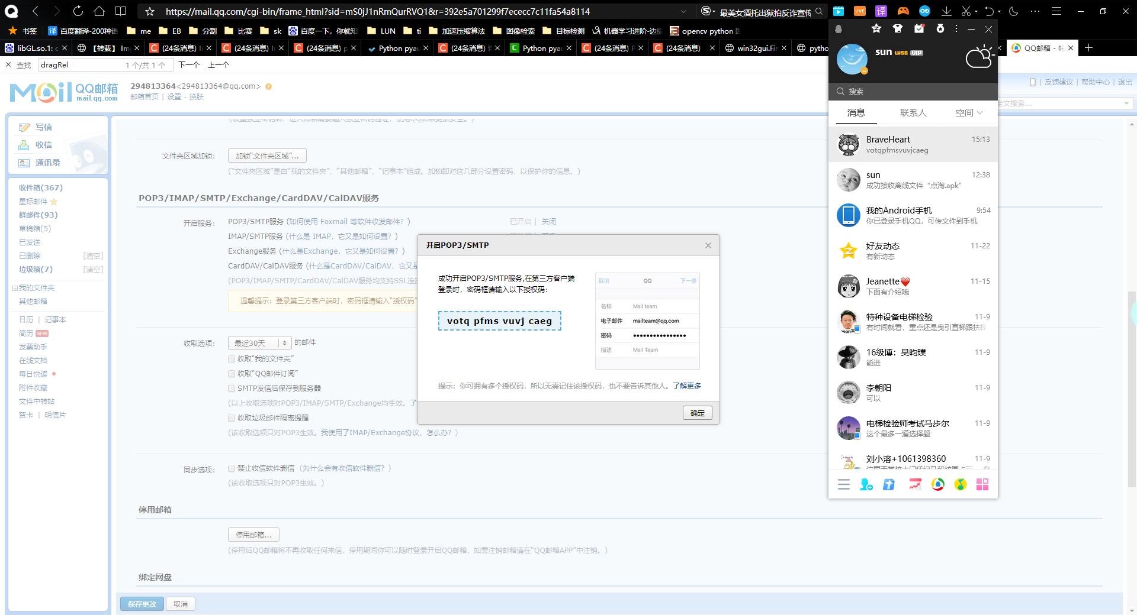

授权码votqpfmsvuvjcaeg
发送邮箱需要设置POP3服务
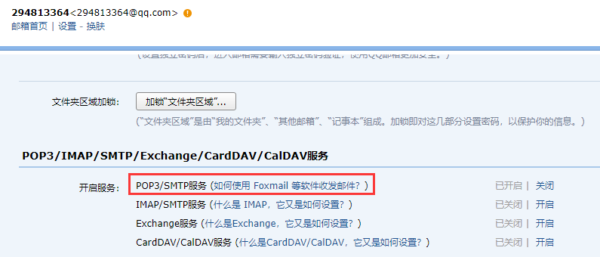
password使用授权码，而不是密码 OK

2.
ModuleNotFoundError: No module named ‘win32gui'
http://www.zhano.cn/python/32874.html
pip install win32gui
后重启命令行窗口，以管理员身份运行。
回到基础环境运行 > conda activate base OK

3.pyautogui出发警告错误
FAILSAFE to False. DISABLING FAIL-SAFE IS NOT RECOMMENDED."
pyautogui.FailSafeException: PyAutoGUI fail-safe triggered from mouse moving to a corner of the screen. To disable this fail-safe, set pyautogui.FAILSAFE to False. DISABLING FAIL-SAFE IS NOT RECOMMENDED.

设置即可pyautogui.FAILSAFE

